## **Index**

|  |  |
| --- | --- |
| **Problem** | **Remarks** |
| 1. Implementation Of Quicksort |  |
| 1. Implementation Of Insertion Sort |  |
| 1. Implementation Of Merge Sort |  |
| 1. Implementation Of Fibonacci Series |  |
| 1. Implementation Of Binary Search |  |
| 1. Fractional Knapsack using Dynamic Programming |  |
| 1. cxMinimum cost spanning tree using Kruskal’s Algorithm |  |
| 1. Implementation Of Euclidean’s Algorithm |  |
| 1. Implementation Of Matrix Chain Multiplication |  |
| 1. Implementation Of Chinese Remainder Theorem |  |
| 1. Solving N-Queen Problem using Backtracking |  |

## **Quicksort**

#include<stdio.h>

void quicksort(int number[25],int first, int last)

{

int i, j, pivot, temp;

if(first<last)

{

pivot=first;

i=first;

j=last;

while(i<j)

{

while(number[i]<=number[pivot]&&i<last)

i++;

while(number[j]>number[pivot])

j--;

if(i<j)

{

temp=number[i];

number[i]=number[j];

number[j]=temp;

}

}

temp=number[pivot];

number[pivot]=number[j];

number[j]=temp;

quicksort(number,first,j-1);

quicksort(number,j+1,last);

}

}

int main(){

int i, count, number[25];

printf("Enter the number of elements: ");

scanf("%d",&count);

printf("Enter %d elements: ", count);

for(i=0;i<count;i++)

scanf("%d",&number[i]);

quicksort(number,0,count-1);

printf("Sorted elements: ");

for(i=0;i<count;i++)

printf(" %d",number[i]);

return 0;

}

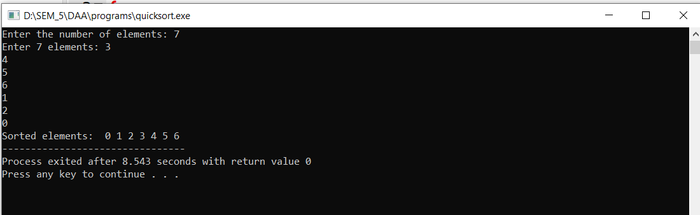

## **Insertion Sort**

#include<stdio.h>

int main()

{

int a[100],i,j,n,s;

printf("Enter number of elements to enter: ");

scanf("%d",&n);

printf("Enter the numbers: ",n);

for(i=0;i<n;i++)

{

scanf("%d",&a[i]);

}

for (i=1;i<n;i++)

{ s=a[i];

j=i-1;

while(j>=0 && a[j]>s)

{

a[j+1]=a[j];

j=j-1;

a[j+1]=s;

}

}

printf("Sorted list in ascending order:\n");

for(i=0;i<n;i++)

{

printf("%d\t", a[i] );

}

}

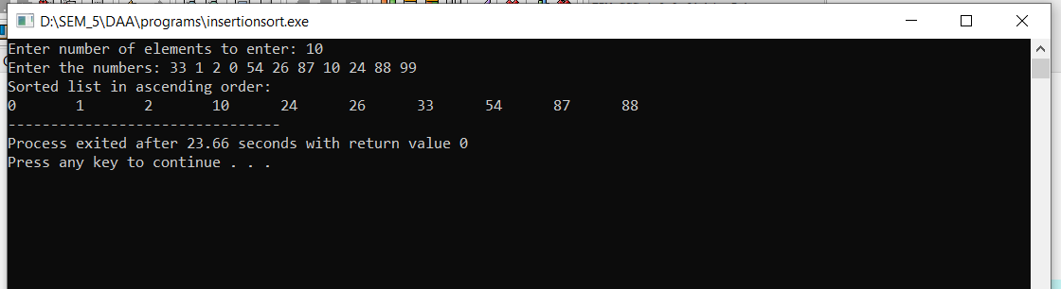

## **Merge Sort**

#include<stdio.h>

void mergesort(int a[],int i,int j);

void merge(int a[],int i1,int j1,int i2,int j2);

int main()

{

int a[30],n,i;

printf("Enter number of elements:");

scanf("%d",&n);

printf("Enter the elements:");

for(i=0;i<n;i++)

scanf("%d",&a[i]);

mergesort(a,0,n-1);

printf("\nSorted array is :");

for(i=0;i<n;i++)

printf("%d ",a[i]);

return 0;

}

void mergesort(int a[],int i,int j)

{

int mid;

if(i<j)

{

mid=(i+j)/2;

mergesort(a,i,mid);

mergesort(a,mid+1,j);

merge(a,i,mid,mid+1,j); }

}

void merge(int a[],int i1,int j1,int i2,int j2)

{

int temp[50];

int i,j,k;

i=i1;

j=i2;

k=0;

while(i<=j1 && j<=j2)

{

if(a[i]<a[j])

temp[k++]=a[i++];

else

temp[k++]=a[j++];

}

while(i<=j1)

temp[k++]=a[i++];

while(j<=j2)

temp[k++]=a[j++];

for(i=i1,j=0;i<=j2;i++,j++)

a[i]=temp[j];

}

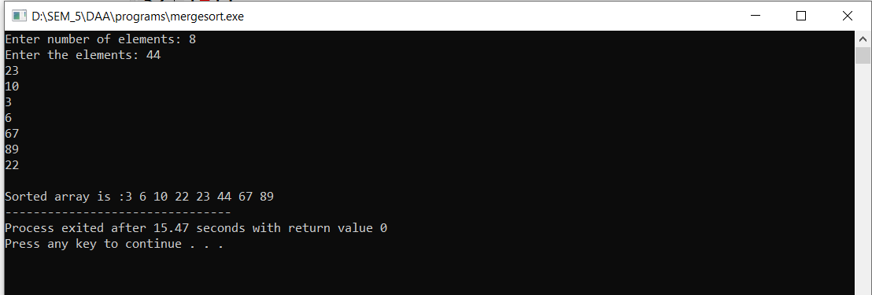

## **Fibonacci**

#include<stdio.h>

#include<conio.h>

int main()

{

int a=0,b=1;

int c,n,i;

printf("Enter n\n");

scanf("%d",&n);

printf("The Fibonacci series is: \n");

for(i=0;i<n;i++)

{

printf("%d\t",a);

c = a+b;

a=b;

b=c;

}

}

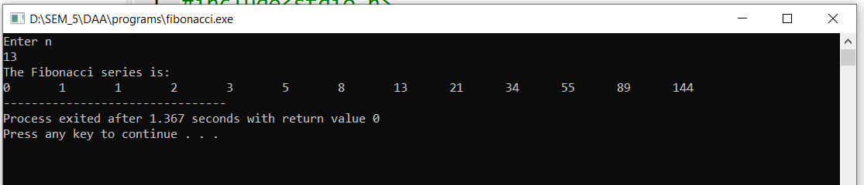

## **Binary Search**

#include <stdio.h>

int main()

{

int c, first, last, middle, n, search, array[100];

printf("Enter number of elements to be entered: \n");

scanf("%d", &n);

printf("Enter %d numbers in sorted order: \n", n);

for (c = 0; c < n; c++)

scanf("%d", &array[c]);

printf("Enter value to search: \n");

scanf("%d", &search);

first = 0;

last = n - 1;

middle = (first+last)/2;

while (first <= last)

{

if (array[middle] < search)

first = middle + 1;

else if (array[middle] == search)

{

printf("%d found at location %d.\n", search, middle+1);

break;

}

else

last = middle - 1;

middle = (first + last)/2;

}

if (first > last)

printf("Not found! %d isn't present in the list.\n", search);

return 0;

}

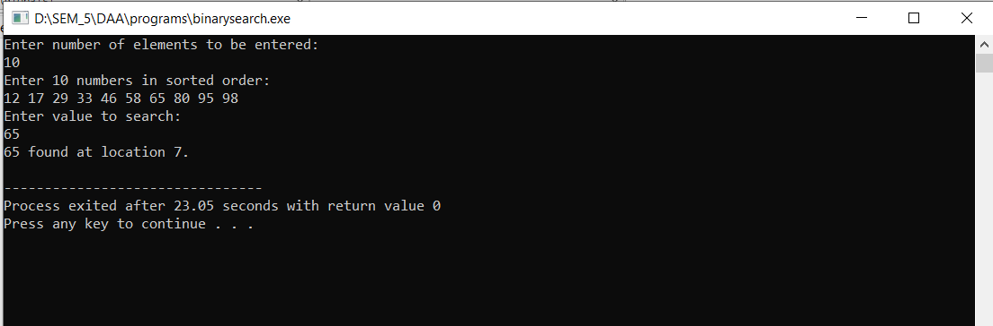

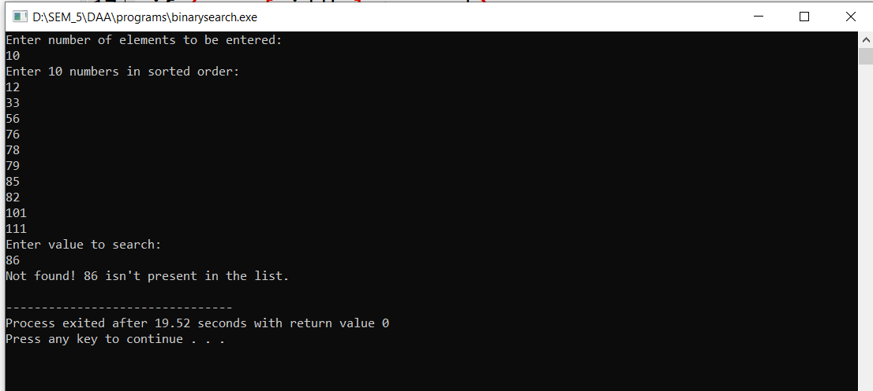

## **Fractional Knapsack**

# include<stdio.h>

void knapsack(int n, float weight[], float profit[], float capacity)

{

float x[20], tp = 0;

int i, j, u;

u = capacity;

for (i = 0; i < n; i++)

x[i] = 0.0;

for (i = 0; i < n; i++)

{

if (weight[i] > u)

break;

else {

x[i] = 1.0;

tp = tp + profit[i];

u = u - weight[i];

}

}

if (i < n)

x[i] = u / weight[i];

tp = tp + (x[i] * profit[i]);

printf("\nThe result vector is:- ");

for (i = 0; i < n; i++)

printf("%f\t", x[i]);

printf("\nMaximum profit is:- %f", tp);

}

int main()

{

float weight[20], profit[20], capacity;

int num, i, j;

float ratio[20], temp;

printf("\nEnter the no. of objects:- ");

scanf("%d", &num);

printf("\nEnter the weightss and profits of each object:- ");

for (i = 0; i < num; i++) {

scanf("%f %f", &weight[i], &profit[i]);

}

printf("\nEnter the capacity of the knapsack:- ");

scanf("%f", &capacity);

for (i = 0; i < num; i++)

{

ratio[i] = profit[i] / weight[i];

}

for (i = 0; i < num; i++)

{

for (j = i + 1; j < num; j++)

{

if (ratio[i] < ratio[j])

{

temp = ratio[j];

ratio[j] = ratio[i];

ratio[i] = temp;

temp = weight[j];

weight[j] = weight[i];

weight[i] = temp;

temp = profit[j];

profit[j] = profit[i];

profit[i] = temp;

}}}

knapsack(num, weight, profit, capacity);

return(0);

}

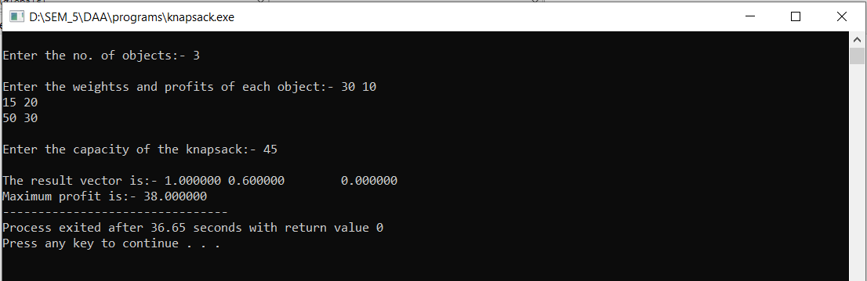

## **Kruskal’s Algorithm**

#include<stdio.h>

#include<conio.h>

#include<stdlib.h>

int i,j,k,a,b,u,v,n,ne=1;

int min,mincost=0,cost[9][9],parent[9];

int find(int);

int uni(int,int);

int main()

{

printf("\nImplementation of Kruskal's algorithm\n");

printf("\nEnter the no. of vertices:");

scanf("%d",&n);

printf("\nEnter the cost adjacency matrix:\n");

for(i=1;i<=n;i++)

{

for(j=1;j<=n;j++)

{

scanf("%d",&cost[i][j]);

if(cost[i][j]==0)

cost[i][j]=999;

}

}

printf("The edges of Minimum Cost Spanning Tree are\n");

while(ne < n)

{

for(i=1,min=999;i<=n;i++)

{

for(j=1;j <= n;j++)

{

if(cost[i][j] < min)

{

min=cost[i][j];

a=u=i;

b=v=j;

}

}

}

u=find(u);

v=find(v);

if(uni(u,v))

{

printf("%d edge (%d,%d) =%d\n",ne++,a,b,min);

mincost +=min;

}

cost[a][b]=cost[b][a]=999;

}

printf("\nMinimum cost = %d\n",mincost);

getch();

}

int find(int i)

{

while(parent[i])

i=parent[i];

return i;

}

int uni(int i,int j)

{

if(i!=j)

{

parent[j]=i;

return 1;

}

return 0;

}

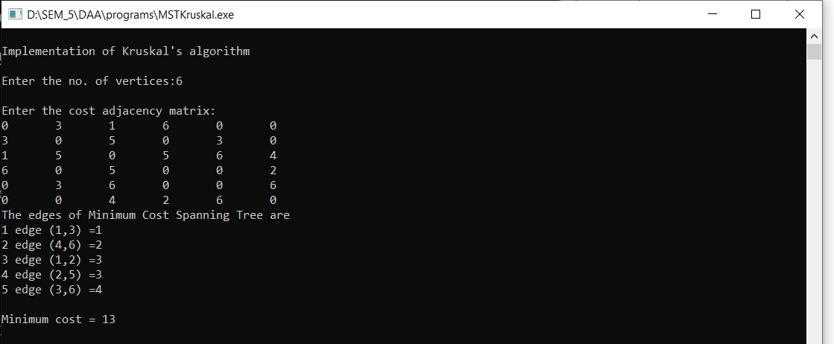

## **Euclidean Algorithm**

#include <stdio.h>

int main()

{

int n1, n2, i, gcd;

printf("Enter two integers: ");

scanf("%d %d", &n1, &n2);

for(i=1; i <= n1 && i <= n2; ++i)

{

if(n1%i==0 && n2%i==0)

gcd = i;

}

printf("G.C.D of %d and %d is %d", n1, n2, gcd);

return 0;

}

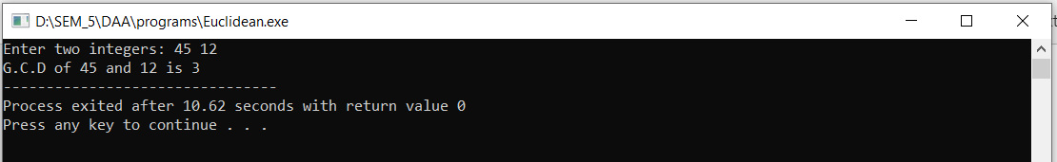

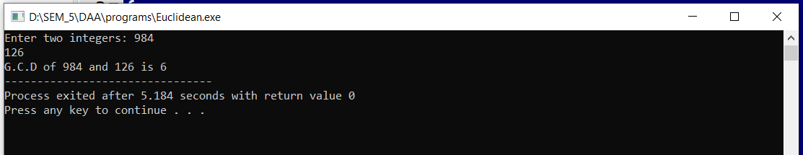

## **Matrix Chain Multiplication**

#include <limits.h>

#include <stdio.h>

int MatrixChainOrder(int p[], int i, int j)

{

if (i == j)

return 0;

int k;

int min = INT_MAX;

int count;

for (k = i; k < j; k++)

{ count = MatrixChainOrder(p, i, k)

+ MatrixChainOrder(p, k + 1, j)

+ p[i - 1] * p[k] * p[j];

if (count < min)

min = count;

}

return min; }

int main()

{

int i,n,arr[100];

printf("Enter number of elements in array: \n");

scanf("%d",&n);

printf("Enter elements:\n");

for(i=0;i<n;i++)

scanf("%d",&arr[i]);

printf("Minimum number of multiplications is %d ",

MatrixChainOrder(arr, 1, n - 1));

getchar();

return 0;

}

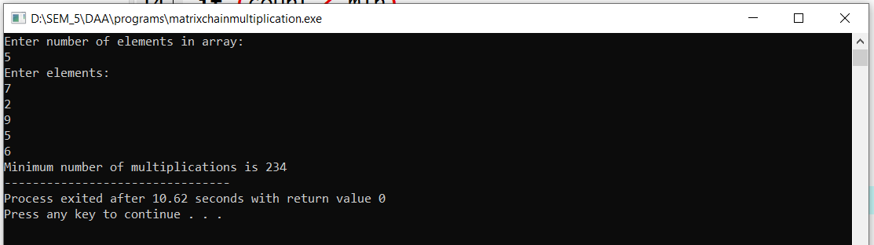

## **Chinese Remainder Theorem**

#include<stdio.h>

#include<stdlib.h>

long long int MMI_BF(long long int e,long long int mod)

{

long long int i;

for(i=1;i<mod;i++)

if((e*i)%mod==1)

return i;

}

int main()

{

long long int i,n,*a,*b,*m,M,*Marray,answer;

printf("Enter the number of Equations : \n");

scanf("%lld",&n);

a=(long long int*)malloc(sizeof(long long int)*n);

m=(long long int*)malloc(sizeof(long long int)*n);

Marray=(long long int*)malloc(sizeof(long long int)*n);

printf("Enter the array a :\n");

for(i=0;i<n;i++)

scanf("%lld",&a[i]);

printf("Enter the array m (all the elements of m should be pairwise co-prime) :\n");

for(i=0;i<n;i++)

scanf("%lld",&m[i]);

M=1;

for(i=0;i<n;i++)

M*=m[i];

for(i=0;i<n;i++)

Marray[i]=M/m[i];

answer=0;

for(i=0;i<n;i++)

answer = (answer + ((a[i] * Marray[i])%M *

MMI_BF(Marray[i],m[i]))%M)%M;

printf("x = %lld\n",answer);

return 0;

}

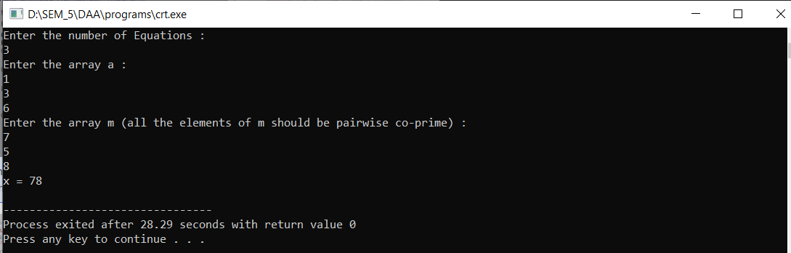

## **N-Queen Problem**

#define N 4

#include <stdbool.h>

#include <stdio.h>

void printSolution(int board[N][N])

{

for (int i = 0; i < N; i++) {

for (int j = 0; j < N; j++)

printf(" %d ", board[i][j]);

printf("\n");

}

}

bool isSafe(int board[N][N], int row, int col)

{

int i, j;

for (i = 0; i < col; i++)

if (board[row][i])

return false;

for (i = row, j = col; i >= 0 && j >= 0; i--, j--)

if (board[i][j])

return false;

for (i = row, j = col; j >= 0 && i < N; i++, j--)

if (board[i][j])

return false;

return true; }

bool solveNQUtil(int board[N][N], int col)

{

if (col >= N)

return true;

for (int i = 0; i < N; i++)

{

if (isSafe(board, i, col))

{

board[i][col] = 1;

if (solveNQUtil(board, col + 1))

return true;

board[i][col] = 0;

}

}

return false;

}

bool solveNQ()

{

int board[N][N] = { { 0, 0, 0, 0 },{ 0, 0, 0, 0 }, { 0, 0, 0, 0 },{ 0, 0, 0, 0 } };

if (solveNQUtil(board, 0) == false)

{

printf("Solution does not exist");

return false;

}

printSolution(board);

return true;

}

int main()

{

solveNQ();

return 0;

}

